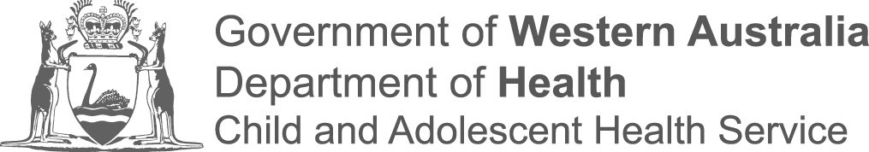
Date:

Dear Doctor

RE:
Affix patient sticker here
Print 2 copies – one for the patient and one for medical records

We saw your patient in the PMH Emergency Department today and made a provisional diagnosis of urinary tract infection.

Investigations
We carried out urinalysis and urine microscopy.
Urine microscopy revealed:

Management in the Emergency Department
We have commenced

at a dose of mls ( ) mg times a day for days.

Management after discharge
We would like you to be involved in the ongoing management of your patient after discharge. We have given the parents/guardian a management plan which involves the following:

Day 2 to 3 – first GP visit
Please call PathWest on 9340 8271 for the results of the urine culture. If the culture is negative cease antibiotics. If positive, continue antibiotics (based on sensitivities) and arrange a second GP visit.

Day 10 – second GP visit
Repeat urine culture (prove clearance).

Follow up for patients under 6 months of age –
we will have already requested an appointment at PMH for a renal tract ultrasound (as an Outpatient). A follow-up appointment has been arranged with the General Medical Team. (Please note: this ultrasound and appointment with the General Medical Team will be cancelled if the initial culture from ED is negative.)

Follow up for patients aged 6 months to 3 years of age -
Please arrange a renal ultrasound scan to ensure that the patient has normal underlying anatomy. If the ultrasound is abnormal or unusual bacteria are found to be causing the UTI, please refer to the PMH General Paediatric Team for Outpatient revew.

Yours sincerely,

